Alertus Technologies’ Unified Mass Notification Products Now Available through Convergint Technologies’ GSA Schedule

Beltsville, MD – October 27, 2016 – The groundbreaking emergency mass notification system from Alertus Technologies® is now available on GSA Schedule 84 through Convergint Technologies. Convergint Technologies has offered integrated alert solutions for the Federal government since acquiring a GSA Schedule in February 2010.
“Safeguarding our Federal government entities is paramount,” said Jason Volk, CEO of Alertus Technologies. “We’re excited to have our life-saving products on the GSA Schedule through our partnership with Convergint Technologies.”

The Alertus Emergency Notification System is a comprehensive unified mass notification solution that can be implemented anywhere and activated quickly and effectively. Its seamless compatibility and integration with a wide variety of existing mass notification systems provides organizations a cost-effective way to enhance their emergency communications efforts.

Included on the GSA Schedule is the Alertus Alert Beacon®. This wall-mounted audible and visual signaling device can be installed almost anywhere and provides notification coverage where other systems may be impractical or cost-prohibitive.

Other Alertus products on the GSA Schedule include the Alertus Desktop™ Notification, Digital Signage Override, Text-to-Speech Interface Module for public address and giant outdoor speaker systems, Fire Alarm Control Panel Interface, VoIP Notification, and panic buttons.
“We are excited to offer the Alertus Emergency Notification solution through our GSA Schedule,” said Vincent Piau, General Manager of Convergint Government Solutions. “We are committed to making a daily difference by providing safety and security solutions for our government clients, and by expanding our GSA schedule emergency notification systems offerings with Alertus, we are holding true to that commitment.”
GSA establishes long-term, government-wide contracts to provide access to millions of commercial products and services at volume discount pricing, streamlining the buying process for federal, state, and local government entities.

Media Contact
Greg Smith, Public Relations Manager
866.425.3788 x784 | gsmith@alertus.com

Media Contact
Tommasina Domel, Marketing Specialist
847.585.8962 | tommasina.domel@convergint.com

About Alertus Technologies
Alertus Technologies® is a pioneer and market leader of emergency mass notification systems for large-area, high occupancy facilities. Since 2002 Alertus has engineered groundbreaking solutions for unified mass notification, in-building notification, outdoor notification, and personal notification. Alertus solutions have been implemented worldwide by thousands of organizations in multiple industries for any number of emergency situations. www.alertus.com.

About Convergint Technologies
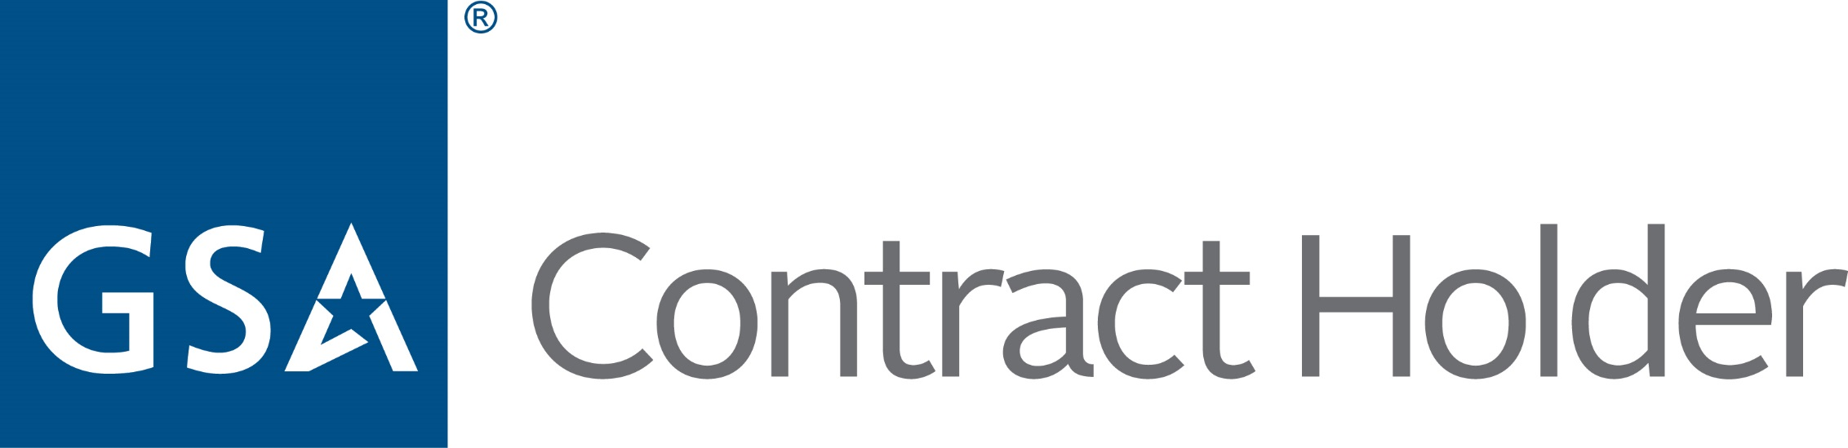
GS-07F-0251W

Convergint Technologies is an industry-leading organization that designs, installs, and services integrated building systems, including electronic security, fire alarm, and life safety systems. To learn more about Convergint, go to www.convergint.com, and visit Convergint’s GSA Advantage page to review available Alertus Emergency Notification System products.

